**PSY 653 Module 5: Repeated Measures and Mixed Designs in ANOVAs**

**ANSWER KEY**

**Gemma Wallace, MS & Neil Yetz**

**Feb 26, 2020**

Use the following experimental design to complete the tasks below:

*There are 30 subjects who each read three passages from one book and rate their liking of the passage. Passages depict A – outdoor activities, B – interactions with family and C – interpersonal conflict, which is resolved. Half of the books are written by male authors (M) and half are written by female authors (F). Books are sampled from two different genres, classic fiction (CF) or modern fiction (MF).*

*The data contains the following variables:*

**Y** = participants’ ratings of how much they liked each passage (the outcome variable)

**Subject** = participant ID number (N = 30)

**Passage** = a 3-level factor variable for the type of passage, coded as either A, B, or C

**Author** = a 2-level factor variable for author self-identified sex, coded as either M or F

**Genre** = a 2-level factor variable for book genre, coded as either CF or MF

**1. Which are within vs. between subject factors? How do you know?**

A within-subjects factor is a predictor variable that is manipulated by testing each subject at each level of the variable. In other words, in within-subjects effects, the *same* participants contribute to multiple means. Within-subjects effects can also be referred to as repeated-measures effects (repeated effects involve measuring the same participants across multiple time points). In contrast, a between-subjects factor is a predictor variable in which different groups of subjects are used for each level of the variable. In other words, in between-subjects effects, *different* participants contribute to different means.

Passages = a within-subjects factor (every participant reads one of each of the three section types)

Author = a between-subjects factor (every participant only reads one book by one author)

Genre = a between-subjects factor (every participant only reads one book from one genre)

**2. Start the F table for this ANOVA by listing the factors (identified as either within-subjects or between-subjects) and their corresponding numerator df. Include the interaction terms that you can test in these data.**

df numerator = (# of levels - 1)

|  |  |  |
| --- | --- | --- |
| Factor | Within-subjects or between-subjects? | df numerator |
| Passage | within-subjects | 3 - 1 = 2 |
| Author | between-subjects | 2 - 1 = 1 |
| Genre | between-subjects | 2 - 1 = 1 |
| Passage*Author | - | 2 * 1 = 2 |
| Passage*Genre | - | 2 * 1 = 2 |
| Author*Genre | - | 1 * 1 = 1 |
| Passage*Author*Genre | - | 2 * 1 * 1 = 2 |
| Residual | - | Calculated from df total = N -1 = 90 - 1 = 89  89 - 2 - 1 - 1 - 2 - 2 - 1 - 2 = 78 |

**3. Use the data file RMexample.csv to conduct the appropriate ANOVA that evaluates only the within-subject effect(s) for this data. You do not need to conduct any planned contrasts or post-hoc analyses.**

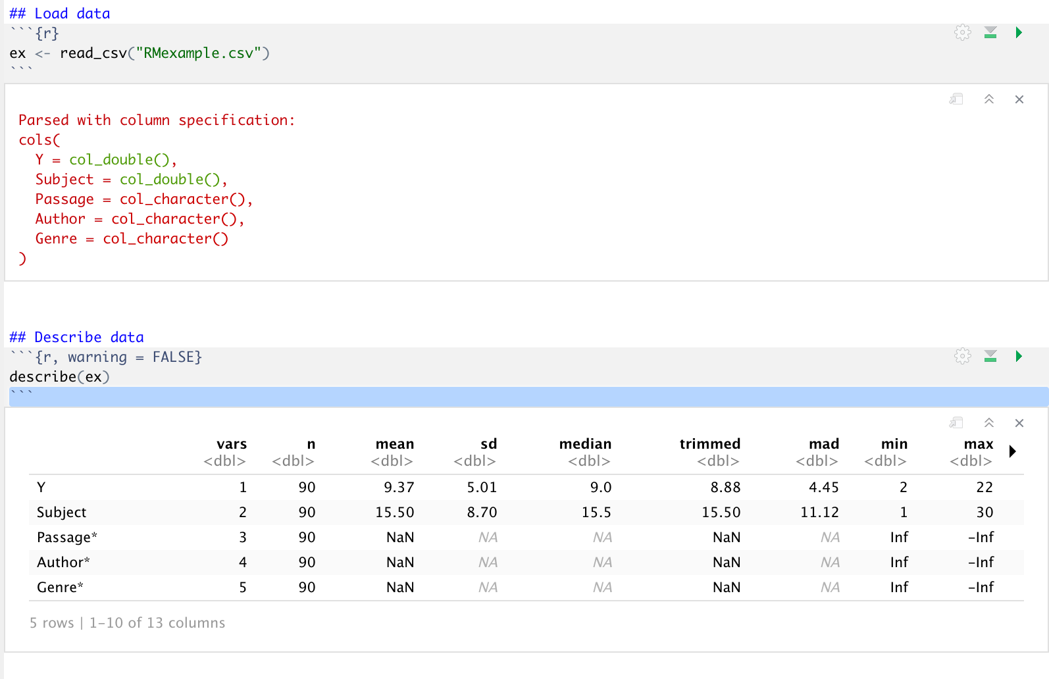

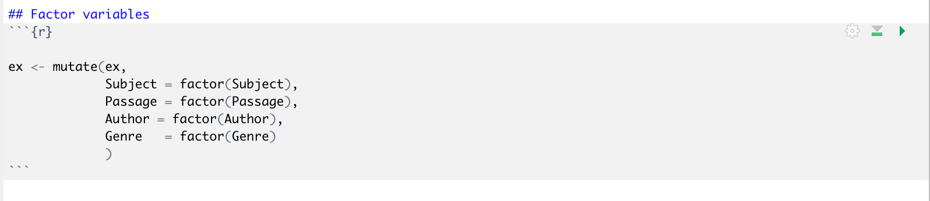

Note: you don’t need to factor the variables, but the ezANOVA() function prefers to work with categorical variables that have been factored.

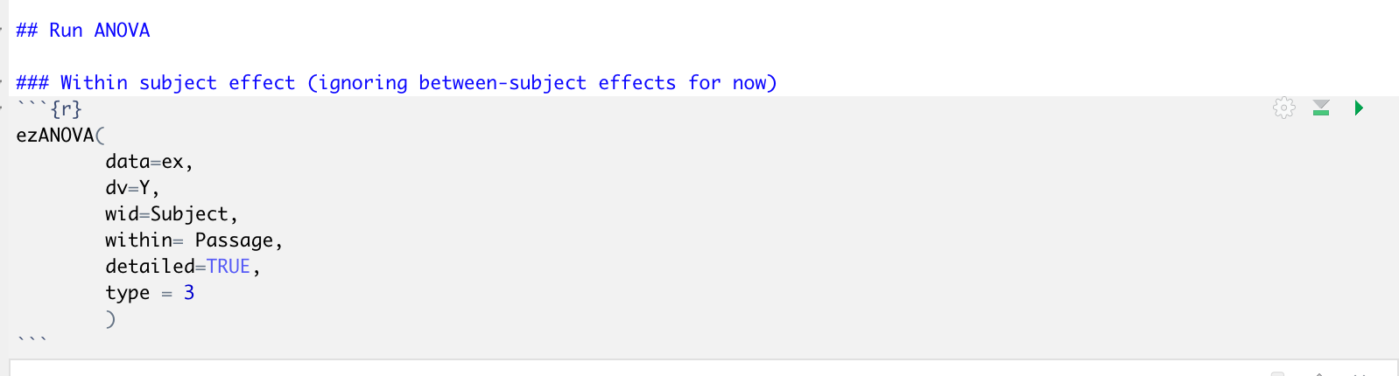

1. **Use the “ez” package in R to conduct the analysis.**

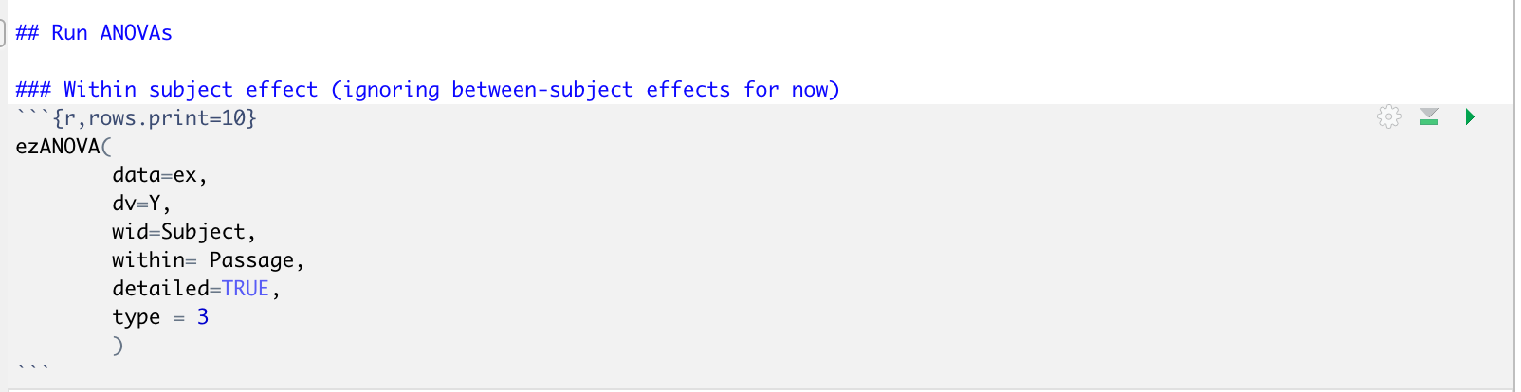

1. **Report and interpret the model results. Include a statement about whether the assumptions of sphericity are violated.**

First, check if the assumption of sphericity is violated by looking at the 3rd output window:

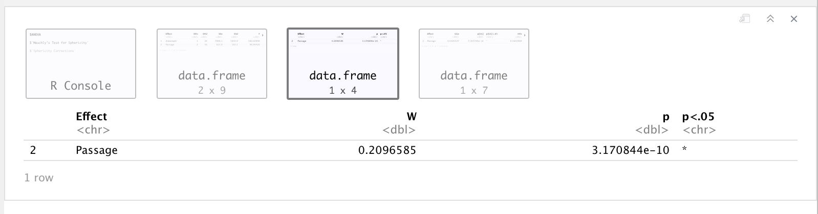

Since p<0.05, we *did* violate the assumption of sphericity in this analysis, indicating that there are differences in the variances across each level of the passage variable. Therefore, we do not interpret the ANOVA table in the second output window and instead, we use the corrected output from the fourth output window in our interpretations.

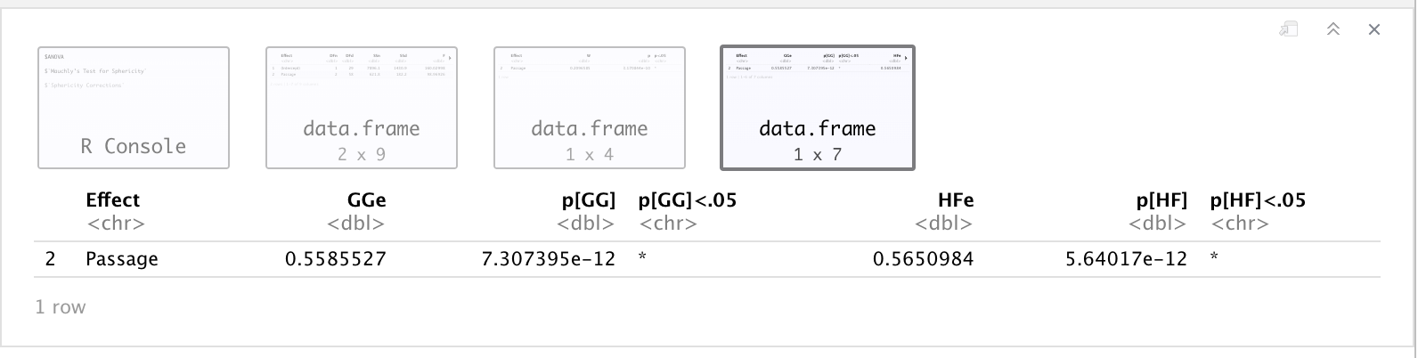

The ezANOVA() function gives us model fit statistics for two different corrections: the Greenhouse-Geisser (GGe) correction and the Huynh-Feldt (HFe) correction. In general, use GGe if sphericity (W) < 0.75 and HFe if W > 0.75. Here, the GGe corrected ANOVA results indicate that Y varies across levels of the passage variable, and since *p*<0.05, this effect is considered statistically significant.

**4. Use the data file RMexample.csv to conduct the appropriate ANOVA that evaluates *both* the within-subject and between-subject effect(s) for this data. You do not need to conduct any planned contrasts or post-hoc analyses.**

1. **Use the “ez” package in R to conduct the analysis.**

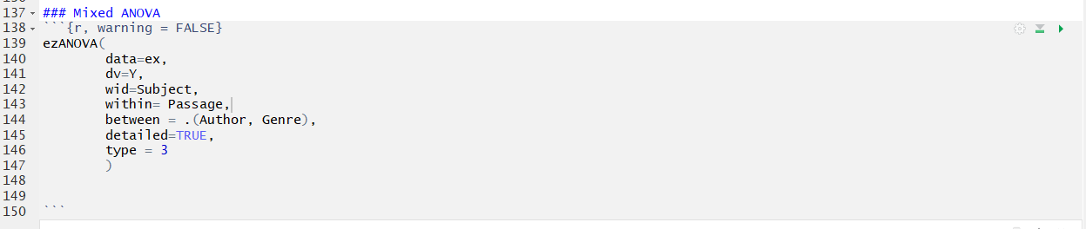

1. **Report and interpret the model results. Include a statement about whether the assumptions of sphericity are violated.**

First, check if the assumption of sphericity is violated by looking at the 3rd output window:

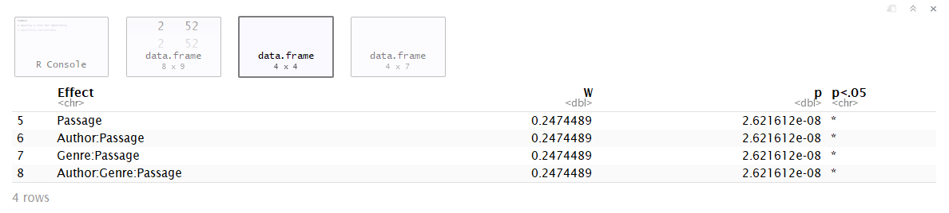

Since p<0.05, we *did* violate the assumption of sphericity in this analysis, indicating that there are differences in the variances across each level of the passage variable. Therefore, we do not interpret the ANOVA table in the second output window and instead, we use the corrected output from the fourth output window in our interpretations.

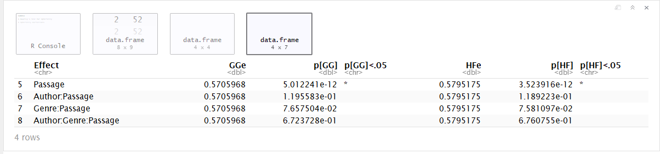

The ezANOVA() function gives us model fit statistics for two different corrections: the Greenhouse-Geisser (GGe) correction and the Huynh-Feldt (HFe) correction. In general, use GGe if sphericity (W) < 0.75 and HFe if W > 0.75. Here, the GGe corrected ANOVA results indicate that Y varies across levels of the passage variable, and since *p*<0.05, this effect is considered statistically significant. However, the interaction between Author & passage, Genre & Passage and the three way interaction between Author, Genre & Passage are not statistically significant. None of the interactions are considered statistically significant.